SPECTRUM ANALYZERS
• Frequency Range : 1.1GHz Bandwidth
• Frequency Range : 3GHz Bandwidth
• With and without tracking generator
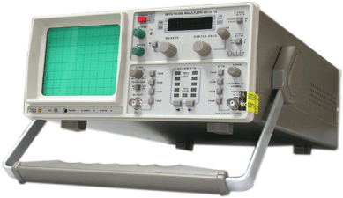 | Spectrum Analyzer 500MHz  with Tracking Generator  Frequency Range : 150 KHz to 500 MHz.  4 ½ Digit Display : Centre & Marker.
Spectrum Analyzer 1050MHz
with Tracking Generator
Frequency Range 0.1 Hz to 1 MHz
Operating Modes: Sine, Square, Triangle
and DC

