ANALOG & DIGITAL OSCILLOSCOPE

Analog Oscilloscope
• 30MHz Dual Trace Oscilloscope
• Channel 1 or 2 trigger signal output
• x-y operation
• High Luminace, internal graticule CRT

DSO ( Digital Storage Oscilloscope)
• 25MHz,50MHz,70MHz,100MHz,250MHz
• 2 Channel
• USB to PC Interface
• Waveform storage
• LCD Display
Oscilloscope Caddo 801
20 MHz Bandwidth.
Sharp Trace CRT & Auto focus.
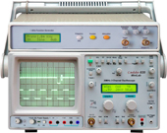 | Oscilloscope MiniLab Caddo 820  20 MHz Oscilloscope.  Component & Continuity Tester.
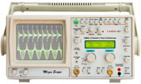 | Oscilloscope Caddo 803  Digital Readout with Backlit LCD  PC interface (USB/RS-232) & Software (optional).
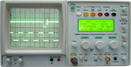 | 30 MHz 2 Channel 4 Trace Digital Readout Oscilloscope Caddo 831  Digital Readout with Large 80 Character Backlit LCD  USB Interface & PC Software (Optional).
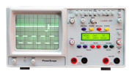 | PowerScope Caddo 829  Floating measurements with completely isolated inputs  1500 V max input.

